**RESUME**

**R.MEENA**

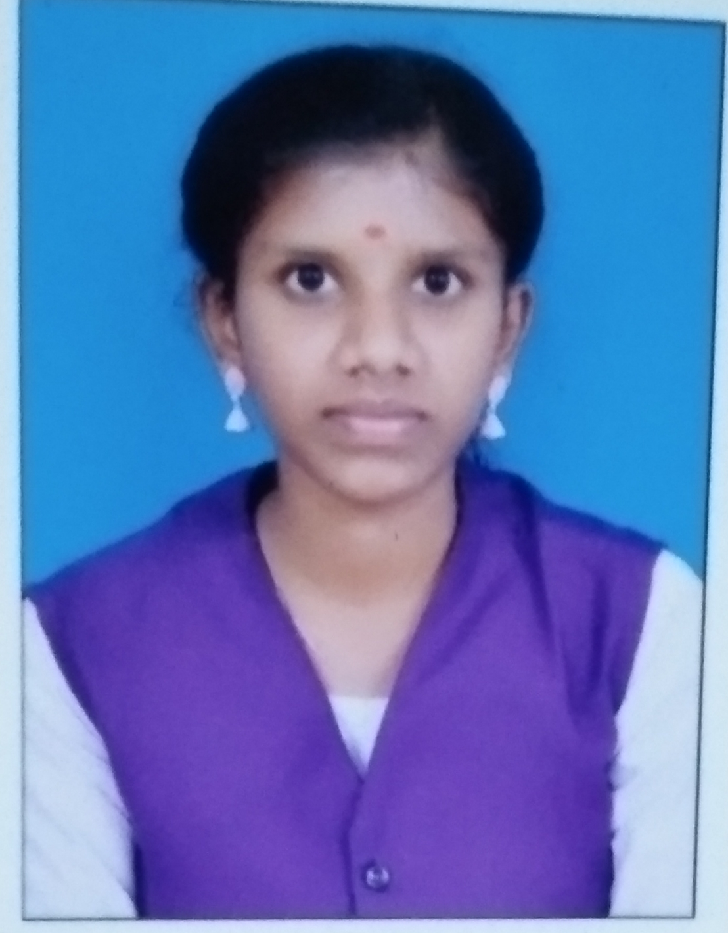

**B.SC COMPUTER SCIENCE**

D/o P.Ramar,

9/340(1), sundaralingapuram,

Pethanadarpatti,

Tenkasi-627808.

Email: rmeena3030947@gmail.com

Mobile No: 9626691856/7603934015

**OBJECTIVE:**

To work in a challenging and creative environment while effectively contributing towards the goals of the organization and myself.

**PROFESSIONAL EXPERIENCE:**

* c basic

**SKILL SET:**

* Having good knowledge about windows operating systems and MS office

**EDUCATIONAL QUALIFICATION:**

* SSLC -63.6%(2019)
* HSC -77.2%(2021)
* Bachelor of Computer Science (SECOND YEAR)
* Government Arts And Science College for Women .Alangulam

#### PERSONAL PROFILE

Name : **R.MEENA**

Father’s Name : P.RAMAR

Date of Birth : 12.04.2004

Sex : Female

Languages Known : Tamil, English

Marital Status : Unmarried

Nationality : Indian

**HOBBIES:**

* Listening Music
* Book reading

**STRENGTHS:**

* Smart and Hard Worker
* Self Confident

**DECLARATION:**

I hereby declare that the information mentioned above is true, complete and correct to

the best of my knowledge and belief.

**Place:** Tenkasi **signature**

**R.Meena**